Here is what I think so far for the game; I am maybe over complicating things.. But I see there being 2 types of playstyles:

1) A freestyle type of play for both 8-ball and 9-ball.

Can add members as you play, thus allowing you to utilize the game QR code. Can play either unlimited or a predetermined number matches in 8-ball, or for 9-ball play regularly but with a different predetermined maximum (or unlimited) number of balls than your skill levels (say I am a 1, they need 14 balls. I can change my maximum to 50). Basically allow a stopping point, or no stopping point to pick back up where you left off.

2) A league type of play where there are 5 matchups (10 designated players, 2 per 1 matchup)

How these players are added are up to the team to decide, it could be completely manual or each group w/players could be pre-populated in the system/manually setup.

**Understanding 8-ball - Handicaps**

8-ball has a certain number of games based on your assigned skill level and the opponent's skill level (skill level/handicap predetermined by gender if you are new, or by the league if you already play)

**8-ball League Style Scoring**

Pre-Game Screen

0. Must pre-register at least one person and one team

1. Need to find the opposing team
2. Manual or automatic skill levels (at least have automatic games must win based on blue chart below)

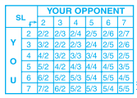

ex) if my.skillLevel=2 && opponent.skillLevel=2, then my.gamesToWin=2 and opponent.gamesToWin=2 and so on… hahal

8-Ball Gameplay Screen Idea (applies to both freestyle and league)

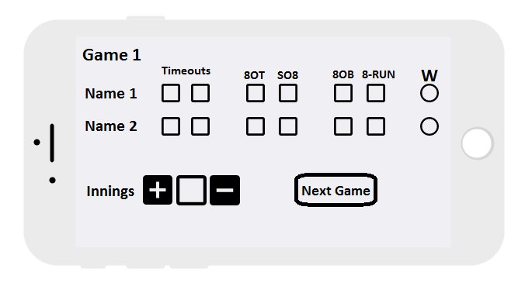

Games: I think each game should be on its own screen to lessen confusion. In League, you can play up to 9 games for 8-ball. Maybe in freestyle, have a limit of 20 games or so to start.

Innings: Every time the person who loses lag/coin toss (bottom player) steps away from the table after shooting, you will add an inning. (innings should start at 0, max 100)

Timeouts: 2 per game.

8OT: 8 out of turn. When 8-ball is made before all of the (solids or stripes) balls are made.

SO8: Scratch on 8. When the person shooting is down to the 8 ball, and they sink the 8-ball and the cue ball on that shot.

8OB: 8 on break. Break and make the 8-ball.

8-RUN: 8 and run. Player consecutively shot all of their balls in and the 8-ball. Other opponent doesn’t shoot at all.

Next Game Button: In order to move to the next game, must be a winner selected for the game. 9 games in total.

End of Match Screen

This sorta is how I envisioned league-style to look..

Freestyle may just keep running total of games won per person.

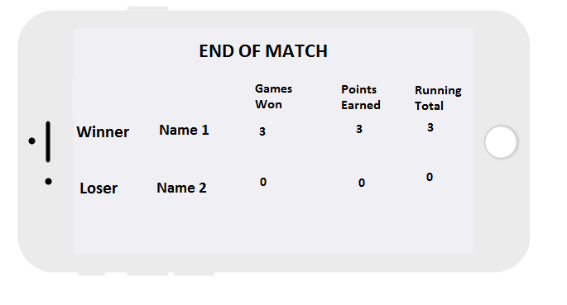

I would like for automatic points earned to be generated on the number of W per person..

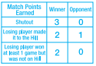

It gets tough because you have to look at this again to determine the number of matches to win..



So maybe just manual points earned entry?

9 Ball Pre Game Screen

With 9-ball, there are predetermined numbers of max balls to make based on your skill level to win the matchup, the number of games do not matter for 9-ball.

9-Ball Gameplay Screen

9-Ball End of Match Screen